**NAME: Jose Ashley**

**ROLL NO: 501826**

**BATCH: B-1**

**DATE: 27.01.2022**

**EXPERIMENT No : 2**

**AIM:** Version control system using GIT.

**LAB OUTCOME:** Examine the different version control strategies.

**THEORY:**

**GIT:**

Git is a distributed version control system for tracking changes in source code during software development. It is designed for coordinating work among programmers, but it can be used to track changes in any set of files. Its goals include speed, data integrity, and support for distributed, non-linear workflows.

**GITHUB:**

GitHub is a web-based Git repository hosting service, which offers all of the distributed revision control and source code management (SCM) functionality of Git as well as adding its own features.

**DIFFERENCE BETWEEN GIT AND GITHUB**

|  |  |
| --- | --- |
| **GIT** | **GITHUB** |
| Git is a software. | GitHub is a service. |
| Git is a command-line tool | GitHub is a graphical user interface |
| Git is installed locally on the system | GitHub is hosted on the web |
| Git is maintained by linux. | GitHub is maintained by microsoft. |
| Git is focused on version control and code sharing. | GitHub is focused on centralized source code hosting. |
| Git is a version control system to manage source code history. | GitHub is a hosting service for Git repositories. |
| Git was first released in 2005. | GitHub was launched in 2008. |
| Git has no user management feature. | GitHub has built-in user management feature. |

**OUTPUT:**

Initialize repository

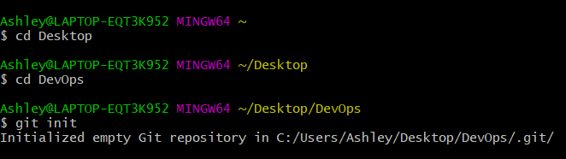

Create files in directory

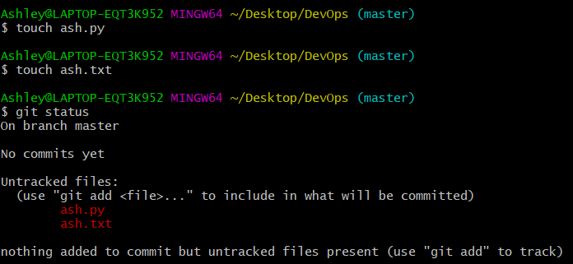

Adding files to repository

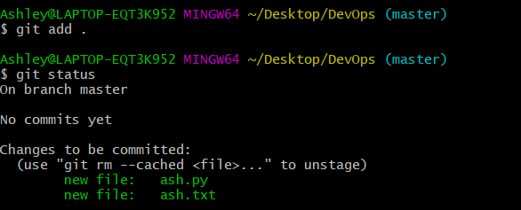

Committing files to repository

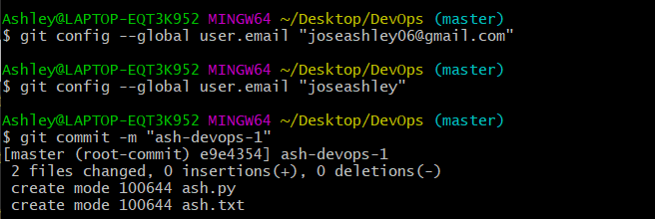

Making changes to a file after committing to the repository:

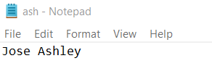

Status after making changes

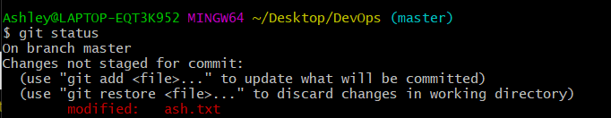

Now that we have made changes, we need to commit again, however, this time we will add and commit only one file and not the entire directory.

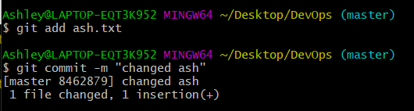



Removing file

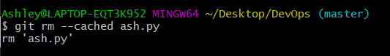

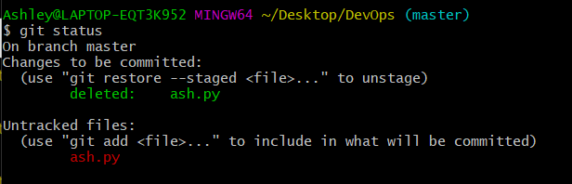

Commit the deletion

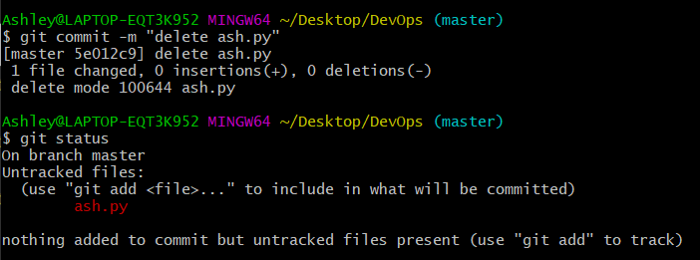

Working with remote repositories:

Create a new repository on Github. (Here, it is called “ash-devops-1”)

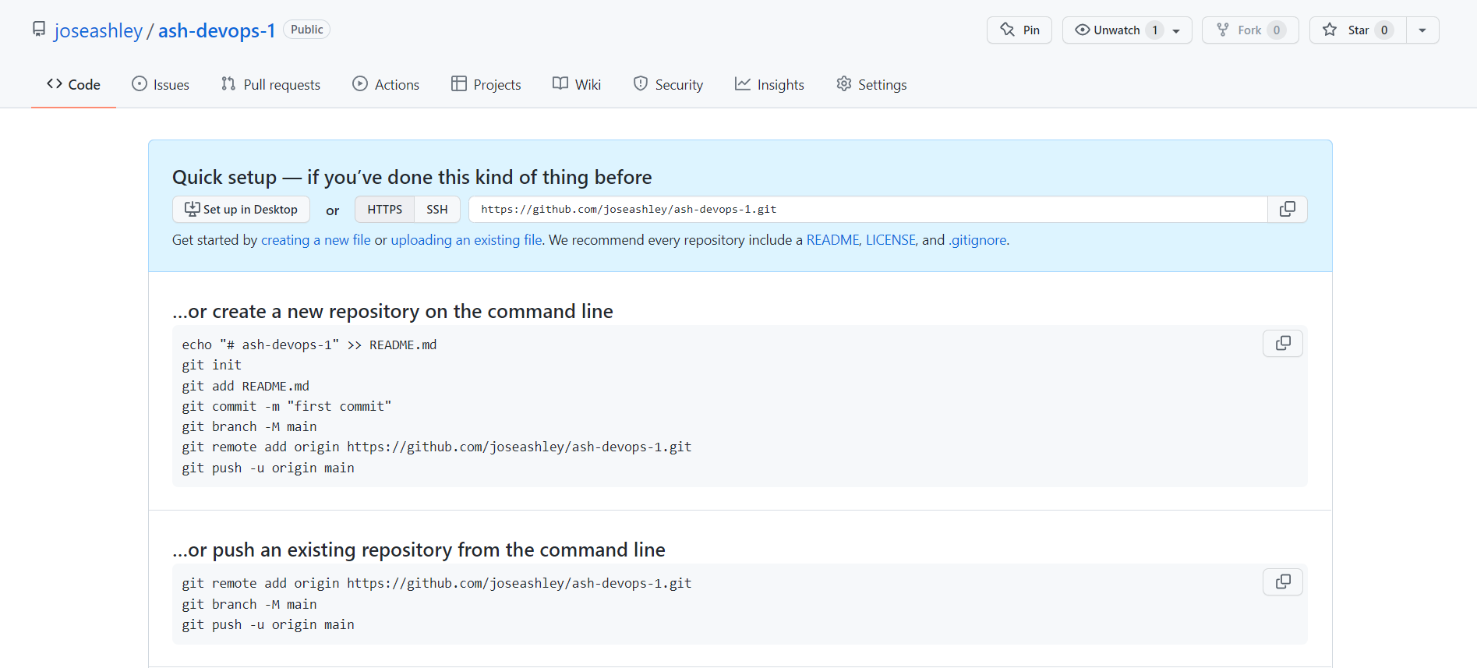

Create remote repository

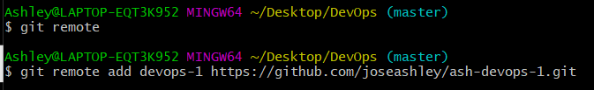

Push code from local repository to remote repository

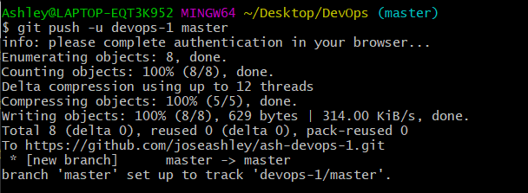

The file from our local repository has been added to the remote Github repository.

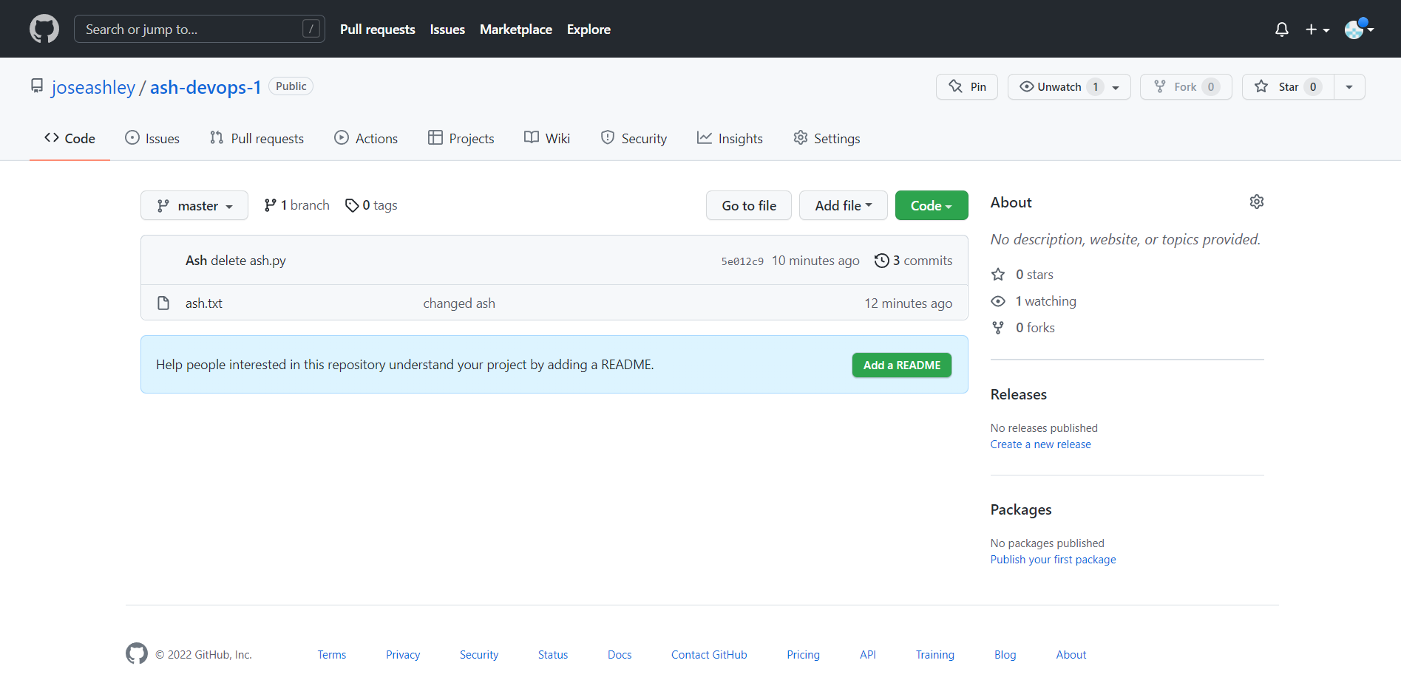

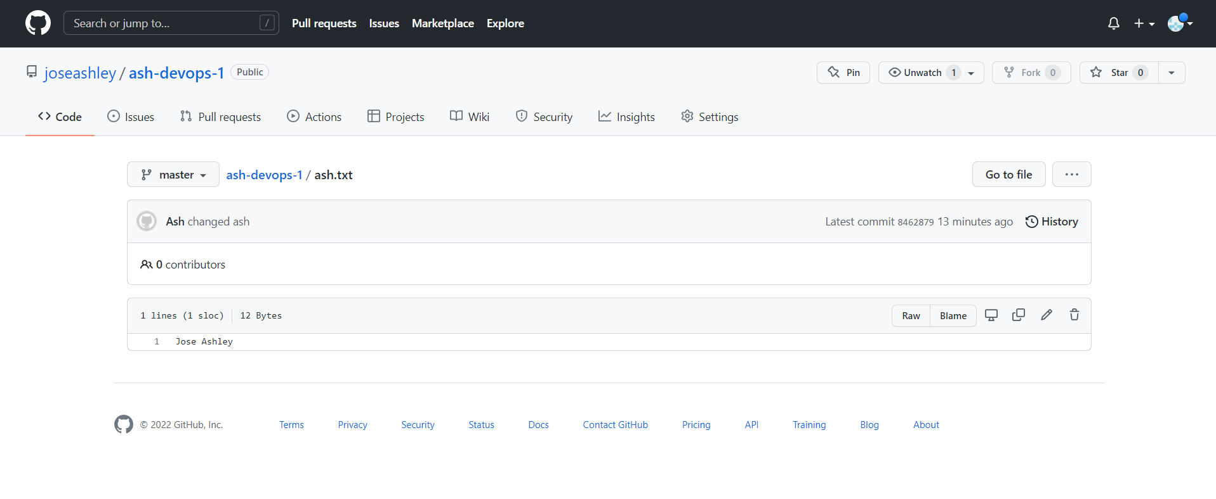

All the changes previously made have also been recorded:

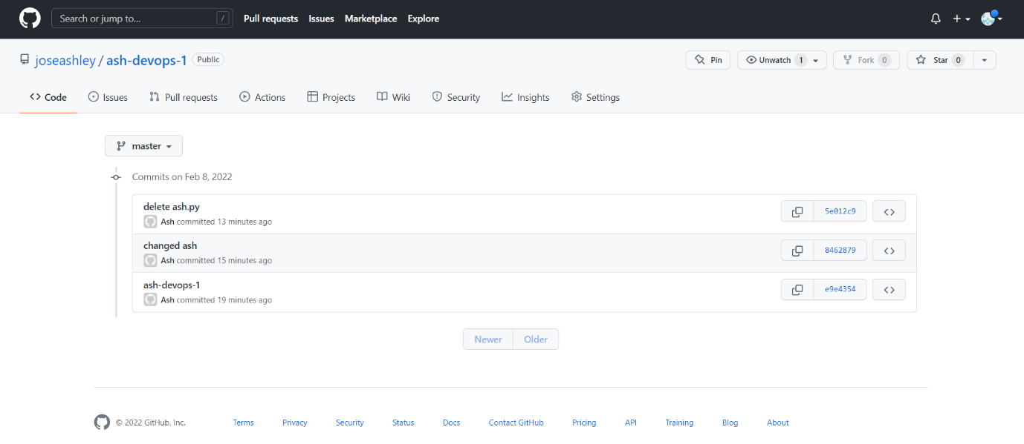

**CONCLUSION:** We successfully implemented the version control system using GIT.